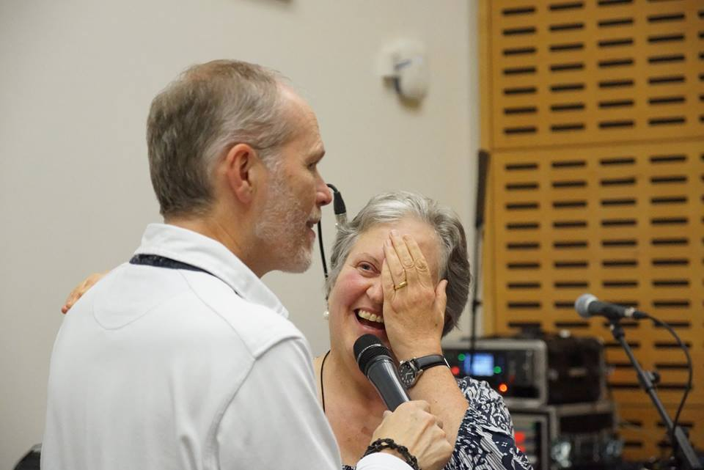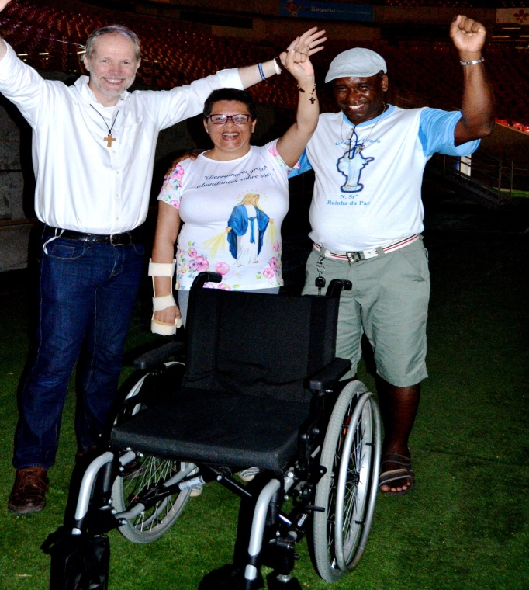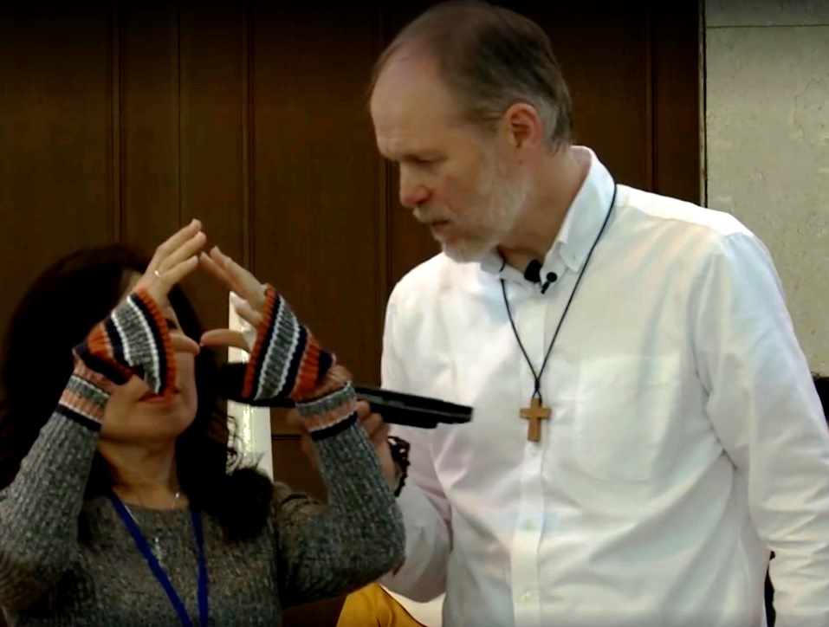

**Freed from walking frame**

**Praise and Adoration**

© Copyright Cor et Lumen Christi Community 2017

Reg. Charity No. 1049357

**Chronic skin condition from birth healed**

**Freed from wheelchair**

**Huge tumour disappears**

**Blind eye Sees**

**20th March 2018 from 7:30 pm**

**With**

**Damian Stayne**

**Church of St. Edmund of Canterbury, 20 Village Way, Beckenham,**

**Kent, BR3 3NP**

**“Damian Stayne touched and healed many people in their souls and bodies in our parish.**

**He helped us to discover Jesus' healing power.”**

***Fr Benedict Beddingfield, Parish Priest of St Margaret's, Canning Town***

**“It is amazing to see the multitude of God’s instantaneous healings people testify to at**

**Damian’s events.” Barbara *Tobisch, Medical Doctor***

**FREE - ALL WELCOME**

**Call 01932 565 747 or see www.coretlumenchristi.org for details**

**Prayer for all**